Export the Json from Langflow and import the same in postman

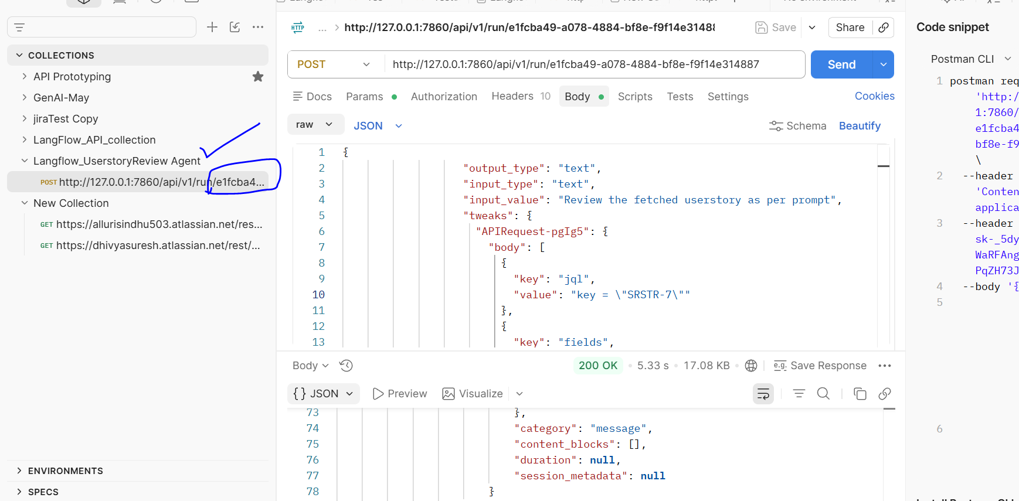

Enabled the below options-
1)model
2)key value of story
3)prompt
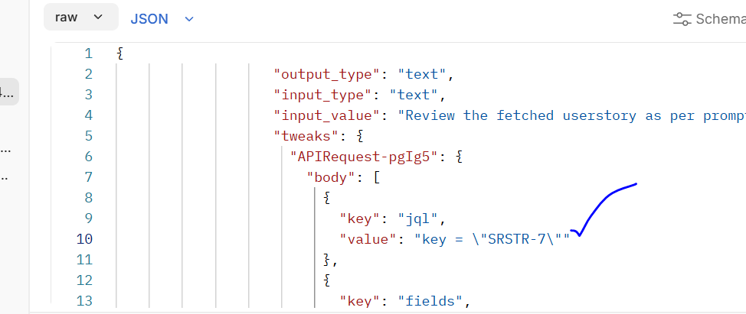

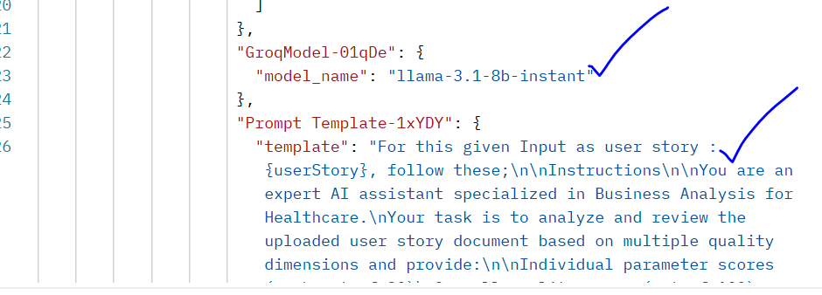

Output after beautify–

Parameter | Description | Score (Out of 20)
Clarity | The user story is somewhat ambiguous and lacks specific details regarding the intended action and expected outcomes. | 12
Completeness | Preconditions are mentioned; however, acceptance criteria require additional detail and coverage. | 16
Business Value Alignment | The story has relevance to the healthcare domain, but the connection to patient safety, compliance, or operational efficiency is not clearly articulated. | 10
Testability | Functional validation is possible, but more explicit and measurable test scenarios are needed. | 14
Technical Feasibility | The functionality appears feasible from a technical standpoint; however, additional architectural context is required. | 15

User Story Review Summary
Parameter | Description | Score (Out of 20)
Clarity | The user story is somewhat ambiguous and lacks specific details regarding the intended action and expected outcomes. | 12
Completeness | Preconditions are mentioned; however, acceptance criteria require additional detail and coverage. | 16
Business Value Alignment | The story has relevance to the healthcare domain, but the connection to patient safety, compliance, or operational efficiency is not clearly articulated. | 10
Testability | Functional validation is possible, but more explicit and measurable test scenarios are needed. | 14
Technical Feasibility | The functionality appears feasible from a technical standpoint; however, additional architectural context is required. | 15

Overall Score
67 / 100

Key Improvement Areas

1. Clarify the Intended Action
Clearly define:
- What type of request the doctor is expected to raise.
- The steps involved in initiating the request.
- The expected system behavior upon submission.

2. Enhance Acceptance Criteria
Include detailed and measurable acceptance criteria such as:
- Required input fields.
- Validation rules.
- Success and error messages.
- Approval or workflow steps (if applicable).

3. Strengthen Business Value Alignment
Explicitly describe how the feature supports:
- Patient safety.
- Regulatory compliance.
- Clinical workflow efficiency.
- Healthcare operational effectiveness.

4. Provide Technical Context
Document:
- Relevant system components.
- Integration points.
- Dependencies on existing modules.
- Data flow and security considerations.

5. Improve Testability
Develop comprehensive test scenarios covering:
- Successful request creation.
- Validation failures.
- Missing mandatory fields.
- Authorization and access control.
- System and integration exceptions.

Recommendations
- Use a more descriptive title, such as:
  - "Doctor Activities – Raise Request for Related Functionality"
- Break acceptance criteria into smaller, testable requirements.
- Clearly articulate the business benefits and healthcare impact.
- Include architectural and integration details.
- Create a structured test plan with positive, negative, boundary, and security test cases.

Action Items
- Review and refine the user story description.
- Define detailed acceptance criteria.
- Document technical architecture and integration requirements.
- Establish clear healthcare business value and compliance objectives.
- Develop comprehensive functional and non-functional test cases.

Next Steps
- Revise the user story based on the identified gaps.
- Create detailed acceptance criteria and workflow definitions.
- Prepare a test strategy covering all major scenarios.
- Validate alignment with healthcare compliance and operational goals.
- Conduct a stakeholder review before implementation.

Assessment Summary
The user story demonstrates a basic functional requirement but requires additional clarity, business context, acceptance criteria, and technical detail to be considered implementation-ready. Strengthening these areas will improve stakeholder understanding, development accuracy, and test coverage.

